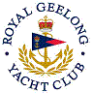 | Royal Geelong Yacht Club Inc.  Est 1859
Trophy Deed of Gift.

Trophy: | Mayor of Geelong Cup
Presented by: | Cr Jim Fidge J.P.
Date: | 1988
For: | Best Dressed Yacht on Opening Day
Remarks / Revisions
Click here for list Recipients

